TECHNICAL REPORT ON STUDENT INDUSTRIAL WORK EXPERIENCE SCHEME (SIWES)

HELD AT
ARCHTECTURAL INTERNSHIP CENTER,
YOLA, ADAMAWA STATE

FROM: 6TH OCTOBER, 2024
TO: 29TH JANUARY, 2025

TITLE PAGE

BY
SUNDAY EMOKENE
(SE/ARC/ND/23/008)

SUBMITTED TO THE DEPARTMENT OF ARCHITECTURAL TECHNOLOGY, FEDERAL POLYTECHNIC MUBI, IN PARTIAL FULFILLMENT OF THE REQUIREMENT FOR THE AWARD OF NATIONAL DIPLOMA (ND) IN ARCHITECTURAL TECHNOLOGY

APRIL, 2025

DECLARATION
This is to declare that I, SUNDAY EMOKENE with registration number SE/ARC/ND/23/008 undertook my four months SIWES at ARCHITECTURAL INTERNSHIP CENTER, YOLA, ADAMAWAW STATE and have acquired all the experience compiled in this report in the course of my SIWES.

……………………………….. ……………………………
SUNDAY EMOKENE Sign/Date

CERTIFICATION
This is to certify that this report compiled by me SUNDAY EMOKENE (SE/ARC/ND/23/008) and meets the regulations governing the award of National Diploma (ND) Architectural Technology of the Federal Polytechnic Mubi.

………………………………. ……………………
Name of Supervisor Date
Departmental Supervisor

………………………………. ……………………
Arc. Daniel Nathan Barka Date
Departmental SIWES Coordinator

…………………………………. ……………………
Arc. Mohammed Usman Date
Head of Department

DEDICATION
I dedicate this technical report to my parents, my sisters and colleagues and to all those that supported me throughout my industrial training.

ACKNOWLEDGEMENT
First of all, my sincere appreciation goes to Almighty God and salutation to my Lord Jesus Christ.
I wish to thank all staff of Architectural Technology Department in Federal Polytechnic, Mubi.
My appreciation goes to my beloved parent for the motivation, prayers and financial support towards my SIWES exercise.
My special thanks go to my beloved brothers and sisters for all their care and support throughout my industrial training.
I want to also thank my colleagues and others; I really appreciate your efforts.

TABLE OF CONTENTS
TITLE PAGE i
DECLARATION ii
CERTIFICATION iii
DEDICATION iv
ACKNOWLEDGEMENTS v
ABSTRACT vii
CHAPTER ONE 1
1.0 INTRODUCTION 1
1.1 Aim and objective of SIWES 1
1.2 Brief history of SIWES and ITF in Nigeria 2
1.3 Significance of SIWES to students 2
CHAPTER TWO 4
2.0 Internship center 4
2.1 Brief history of architectural internship center 4
2.2 Company organogram 4
CHAPTER THREE 5
3.0 DESCRIPTION OF WORK EXPERIENCE 5
3.1 Setting out 5
3.2 Site clearance 6
3.3 Excavation of foundation 7
3.4 Block work 9
3.5 Casting 10
3.6 Setting of pillars and column base 13
CHAPTER FOUR 14
4.0 SUMMARY, RECOMMENDATION AND CONCLUSION 14
4.1 Problems observed during my program 14
4.2 Summary 14
4.3 Conclusion 15
4.4 Recommendations 15
REFERENCES 16

ABSTRACT
The report summarises the result of work done during my SIWES experience, the technical report consists of four chapters, which comprises of introduction, history and criteria’s of SIWES in chapter one followed by their aims and objectives, historical background, organizational structure of the organization in chapter two, while chapter three consist of the work actually carried out during the SIWES programme and lastly chapter four consist of the summary, conclusions and recommendation.

CHAPTER ONE

1.0 INTRODUCTION
The acronym (SIWES) meaning “Student Industrial Work Experience Scheme” is a skill training designed to expose and prepare student in higher institution to industrial working situation they may likely meet after graduation. The scheme is meant to train student on the method of work and the experience needed in handling the equipment and machines may not to be available in their institution. The scheme is financed by the Federal Government and operators through Industrial Training Fund (ITF), Ogwo, (2001) and operates with National University Commission (NUC), National Board of Technical Education (NBTE), and National Commission for College of Education (NCCE) and industries. However, SIWES also expose the student to many practical works which the institution did not treat in details without plastering what the institution taught theoretically into practical. A point from academic obtained. SIWES assist the student to understand the nature of his/her work in future.

1.1 Aim and Objectives of SIWES
ITF initiates SIWES with the sole aim of: Exposing student with the practical experience related to the theoretical knowledge acquired in school. Bridging the gap between theoretical learning and practical work situation.
- To make industries/organization to have confidence in the abilities and capacities of the graduates. SIWES helps the industries to evaluate the prospective employees and give feedback to the institution.
- It helps the student to gain work and also have experience and confidence as a result if successful completion of a given job assigned to them.
- To enlist and strengthen the employers’ involvement in the institution activities and in the entire educational process of preparing the student for meaningful and productive employment into industries.

- It provides an avenue for student in the Nigerian University and Polytechnics to acquire industrial skill and experience in their course of study.
- Development for greater understanding in other people and proffers skills in human relations.

1.2 Brief history of SIWES and ITF in Nigeria
It was said by Dr. Azikiwe Nnamdi, the one president of Nigeria that the practice of work but they all have the same goal that they all want to achieve in countries like china. They established within the premises of institution to provide real life situation, lack of practical skill of locally trained engineers and technologies. the chine way and condition of SIWES is that all institution must give student real life working experience in industrial works. Lecturers are involved in the industrial activities rendering constant services. So, all these countries have their own way of conducting the scheme but all lye on the same goal. And in Nigeria, the history of SIWES can be traced by the history of IITF which is the backbone of SIWES. ITF was established in 1974 under degree of 47 of 1971. It was a body established by the Federal Government of Nigeria and was given responsibility of training indigenous Nigerians. The establishment of the body became necessary due to high demand of Nigeria to take up the vacant positions created in various sector of the economy after the colonial masters have departed. Therefore, the Federal Government discovered that it is easier to train students that are skilled in school to be trained and meet up with gaps in the Nigerian economy and a scheme was established to care for such training and it was named Student Industrial Work Experience Scheme (SIWES). In 1973, the national board of technical education (NBTE) made it compulsory for all the polytechnic students, be it federal or state.

1.3 Significance of SIWES to students
Principles taught in the classroom are vein forced given concrete applications on the industrial assignment and students is able to see the relevance of their students which increase their motivation. It helps in given students the knowledge on the types of work to do after his/her graduation. SIWES given students opportunity for a change of environment as they move their institution to the place of attachment which changes the routine types of environment to a word of work. It helps in connecting the institution and the industrial their relationship the introduction of SIWES.

CHAPTER TWO
2.0 INTERNSHIP CENTER

2.1 BRIEF HISTORY OF ARCHITECTURAL INTERNSHIP CENTER
The Architectural Internship Center, Yola in Adamawa State was founded on the vision of nurturing future architects and building professionals through practical, hands-on experience and mentorship. Established in response to the increasing demand for qualified and skilled personnel in the architecture and construction sector, the center was inspired by the commitment of its founder, Ibrahim Musa, a civil engineer and advocate for sustainable development.
Since its inception in 2015, the center has grown into a reputable institution dedicated to excellence in both architectural training and professional project delivery. With a core mission to empower aspiring architects and engineers, the center combines academic knowledge with real-world application, preparing interns to meet modern design and construction challenges.
The Architectural Internship Center offers a comprehensive range of services, including: Architectural Design, Civil Engineering Services, Project Management, Construction and Renovation, and Consultancy:

2.2 COMPANY ORGANOGRAM
CHAIRMAN
DIRECTOR
MESSENGER
SUPERVISOR
STUDENTS

Figure 2.1: Organogram
Source: Author’s work, 2025

CHAPTER THREE

3.0 DESCRIPTION OF WORK EXPERIENCE

3.1 Setting Out
Square method was used for the setting out, as observed after 90 from all angles using the pages ropes string and also from the plan. Setting out is done with high degree of accuracy or else the building will not last as the engineer answered to my question “why are some calculations made during setting out”.
The method of the setting out used at the site is the builder’s square method
Procedure for the builder’s square method of the setting out:
- After site clearance material to be used were made available at the site.
- Proper site measurement was taken and all angles of the site were noted.
- Lines and blocks to be used were made available.
- Builder’s square was used to align the blocks and a line was used to extend the alignment to another angle of the site as specified in the floor plan, this was done continuously.
- The same method was applied to obtain all the angles of the building, by using this procedure demarcation, foundation boundary was made which brings about the starting point of excavation.
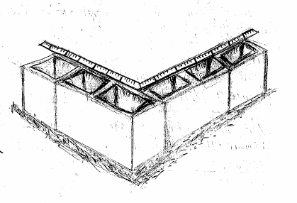
Plate 3.1: Setting out using builder’s square method
Source: Author’s work, 2025

3.2 SITE CLEARANCE
Before the excavation of the proposed foundation commences, we cleared the site. So therefore, site clearance is the removal of all accumulated waste from an area to ensure that it is free from any environmental hazard, obstacle or unsightly mess.

3.3 EXCAVATION OF FOUNDATION
Excavation can be defined as the process of digging a soil surface or trench for foundation lay into trench.
It is also the process of removing top soil for foundation trenches. Excavation work is an important part of building operation that commences immediately after setting out the width of excavation for foundation trenches is marked out on the profile and then transferred to the ground. Excavation must be carried out carefully to ensure safety of workers.
Excavation can be done using two methods mechanical and manual. In small construction we normally use manual method while in large construction we use mechanical e.g. like road construction.
Excavation work were carried out manually where unskilled labourer where involved with digger, shovels, head pan and wheel barrow. The following factors must be considered when carrying out any excavation work.
- Nature of the soil
- The width and depth of foundation
- Climatic condition at the time of excavation
- The water table of the soil
- The period excavation work is expected to be left open.
- The effect of excavation on existing adjacent structure.
As the engineer and the former goes to set basket, I was keeping an eye on how the beams were set. When digging the basket some places were 1.2 while some other places were 1.4 by 1.4 because of the type of soil on the site. When putting the basket in a poor soil, cement and sharp sand is mixed out before putting the basket to avoid rusting.

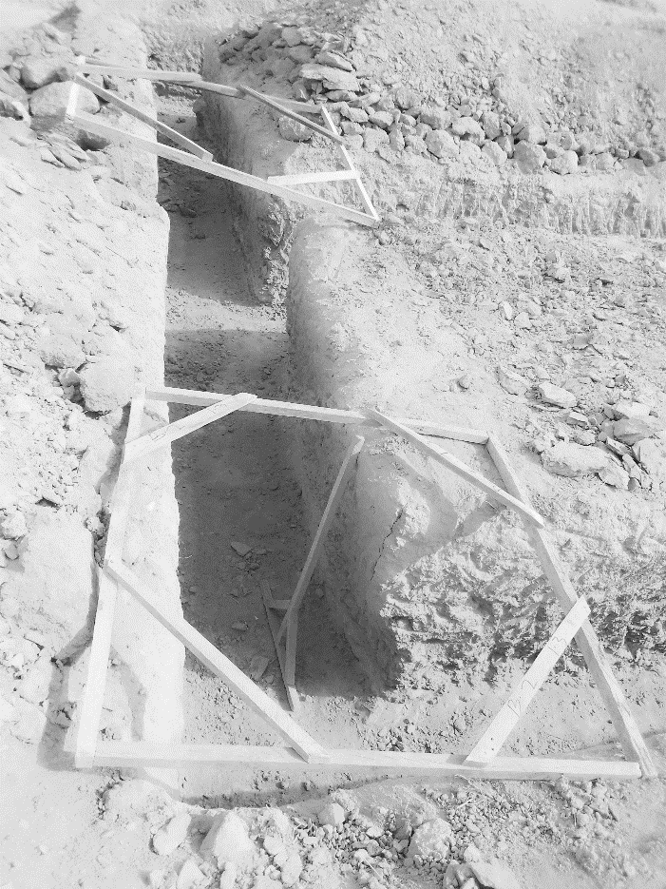
Plate 3.2: Excavation
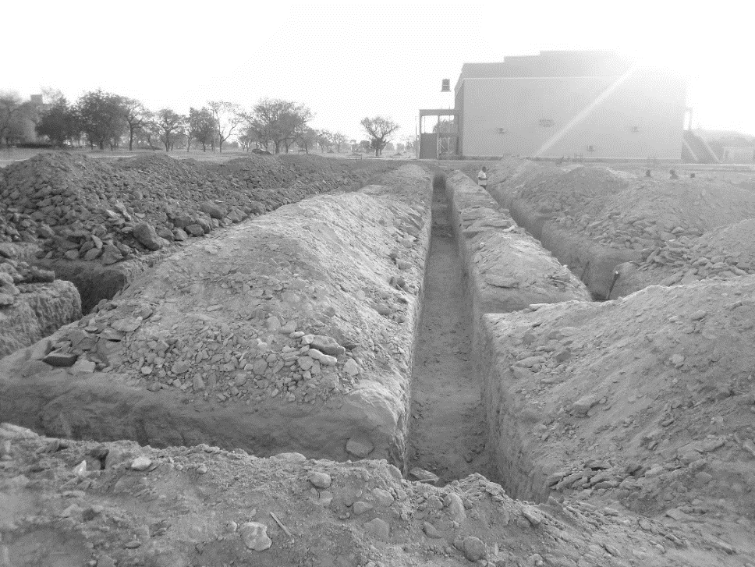
Source: Author’s work, 2025

Plate 3.3: Excavation
Source: Author’s work, 2025

3.4 BLOCK WORK
Blocks were molded in a number of sizes, various compositions, strengths, and shapes such as 9 inches and 6 inches. The 9-inch blocks were used for external walls, while the 6-inch ones were for internal walls. After the foundation work was finished, the blockwork was built to cover the spaces as well. All the blockwork did not carry any load; they were erected to cover spaces and also act as partition walls.
Procedure
- Before starting the block laying process, the site was prepared by clearing debris and ensuring a level foundation.
- The layout of the walls or structure was marked using chalk lines or strings to guide the placement of the blocks.
- Blocks or bricks were selected based on the desired strength, size, and aesthetic requirements of the project.
- Mortar was mixed according to the specifications, typically using a combination of cement, sand, and water.
- A layer of mortar was spread evenly along the foundation where the first course of blocks would be placed.
- A level was used to check the horizontal and vertical alignment of the blocks.
- Once the first course was laid, additional courses of blocks were added on top, following the same process.
- Each block was buttered with mortar on its ends before being placed to ensure a strong bond between the blocks.
- Blocks may have needed to be cut to fit around corners, openings for doors or windows, or to maintain the desired pattern.
- Excess mortar was scraped off the joints using a trowel, and any gaps or voids were filled to create a smooth, uniform surface.
- Once the block laying was complete, the work area was cleaned up, and any excess materials or debris were removed from the site.
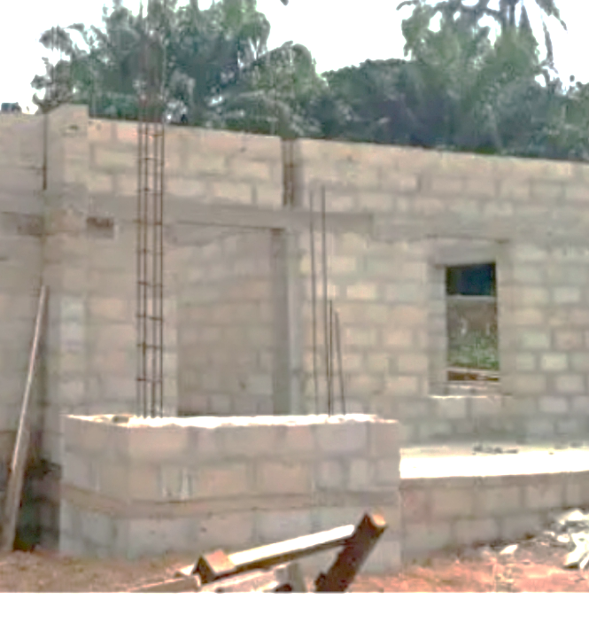
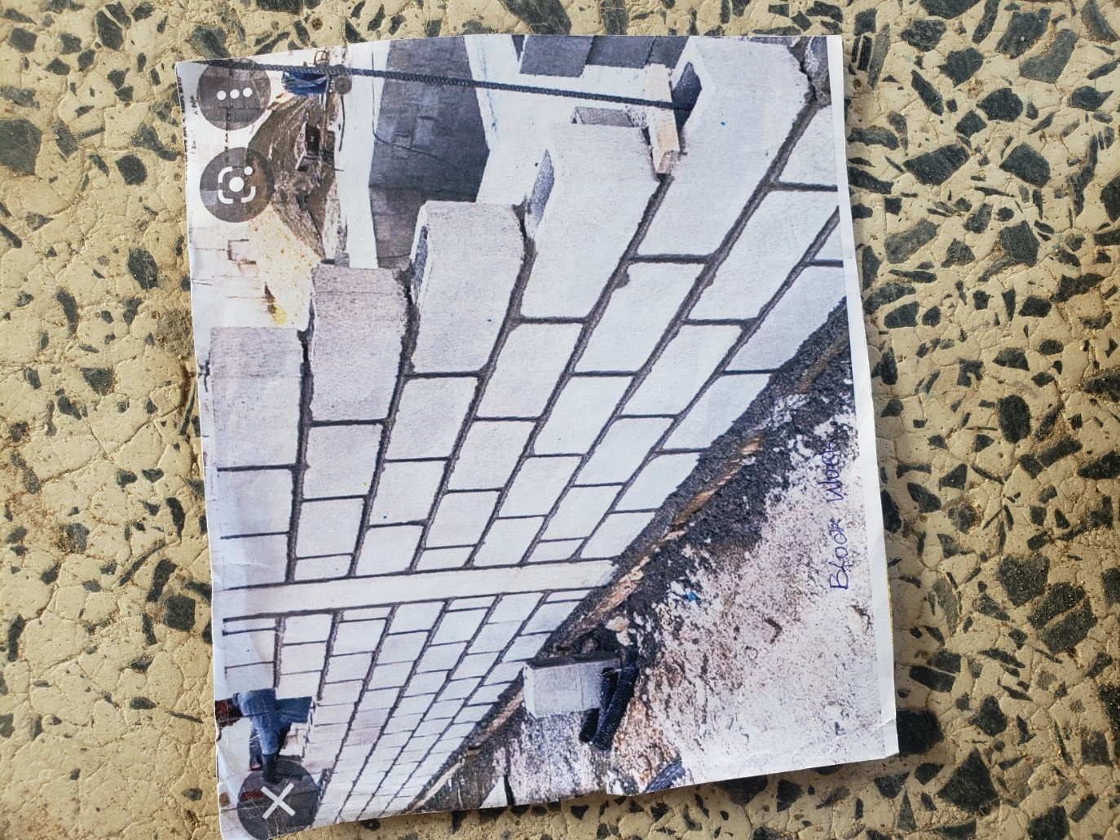
Plate 3.4: Block work
Source: Author’s work, 2025

3.5 Casting
Casting is a fundamental process in construction, involving the pouring of concrete into molds or formwork to create various structural elements. This section involves the casting procedures carried out for down beams, lintels, upper beams, and floors.
3.5.1 Casting of Ground Beam
- Formwork was prepared and set up according to specifications.
- Reinforcement was placed within the formwork.
- Concrete was poured into the mold and vibrated for compaction.
- The cast down beam was left to cure before the formwork was removed.
- Any surface imperfections were addressed through finishing techniques.
3.5.2 Casting of Lintel
- Formwork was erected, and reinforcement was installed.
- Concrete was poured into the formwork and compacted.
- After curing, the formwork was stripped, revealing the cast lintel.
- Finishing touches were applied to achieve the desired appearance and dimensions.
3.5.3 Casting of Upper Beam
- Formwork was prepared, and reinforcement was placed.
- Concrete was poured into the formwork and compacted.
- The cast upper beam was allowed to cure before the formwork was removed.
- Finishing techniques were employed to address any surface imperfections.
3.8.4 Casting of Floor
- The subbase was prepared, and formwork was installed around the perimeter.
- Reinforcement was placed within the formwork.
- Concrete was poured onto the prepared subbase and leveled.
- After curing, the formwork was removed, revealing the finished floor surface.
- Surface protection measures were implemented to safeguard the newly cast floor.
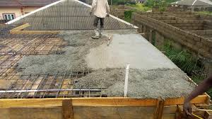
Plate 3.5: Casting of lintel
Source: Author’s work, 2025

3.6 SETTING OF PILLARS AND COLUMN BASE
We usually tie a rope to out or in-to-in and then place our pillar in the middle of the block to make it align and in straight line.
After putting the baskets in their respective positions, the pillars are then set with the ropes (crossed in between the ropes). Then we made sure that the pillar is not touching the rope, and then tied it to the basket with the blinding wear, stroke in the middle of the pillar with braces so that to hold it in position and in line. After that concrete mix is then applied to fill in the 1 feet depth carefully without tempering with the position of the pillar and then being rammed.
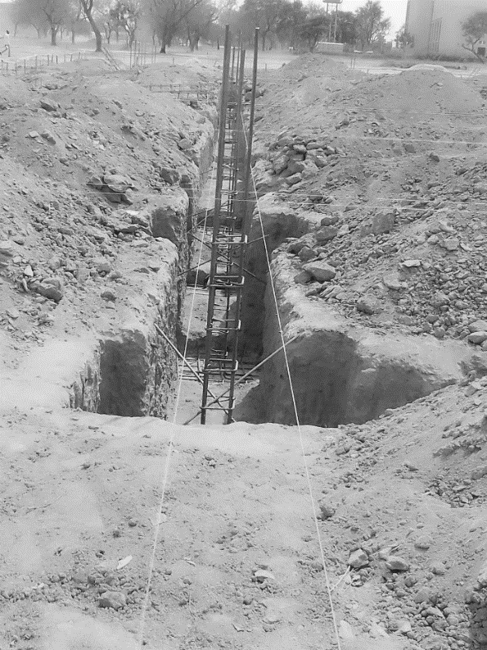
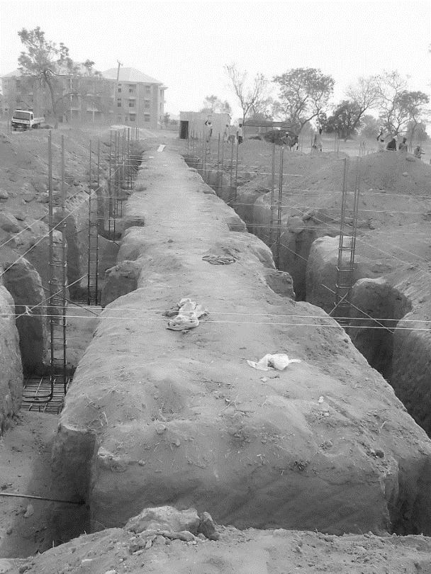
Plate 3.6: Blinding
Source: Author’s work, 2025

CHAPTER FOUR

4.0 SUMMARY, RECOMMENDATION AND CONCLUSION

4.1 CHALLENGES ENCOUNTERED DURING SIWES PROGRAM
- The time frame set for the program is too short as some of the aspects of the program where not completed.
- Lack of Financial support from the company to aid transportation to and from training.
- Attentions are not given to the IT students by the workers it is learn if you want to learn or ask if you want to know.

4.2 SUMMARY
One would state that the discipline is the training of the mind and body towards effective performance. The Students Industrial Work Experience Scheme (SIWES) is more or less achieving this fit. As it further builds on the theoretical classrooms leaving a practical approach of the industry and commerce to supply of finished goods and services. This program has enabled the participating students to be practically involved in the day-by-day activities of the industries and commerce.
Emphasis in the observation of industrial safety rules and regulations, time critical operation and proper man-hand management, quality cortices, etc. are daily activity objective. All those aimed at the production of marketable goods and services in the world of work.
However, to consolidate on the gains of this Industrial Training Fund (ITF) higher institution coordinator on SIWES program should be allowed making some suggestion and recommendation.

4.3 CONCLUSION
SIWES programme is very vital student especially undergraduates, because I come to see the SIWES programme provide an application of the theoretical knowledge learned by student in school to practical or real work situation. Also, it is a medium where student from different higher institutions and department come together sharing idea there, by promoting an avenue for learning and them work.

4.4 RECOMMENDATIONS
Having being exposed to a bit of what entail working in an individual related to my course of study under SIWES programme I wish to make this recommendation
- Higher instruction of learning especially either institution and universities should establish link with comprise and establishment so as to provide space for student on industrial attachment, with the option of gaining employment in future, by doing so, it will go a long way in alleviating suffering and difficulties encountered by student in securing place for individual attachment.
- Student should put money as the primary aim of going SIWES programme, there is more to learn than Bain allowance.

REFERENCES
Chudley, R. (2005). Construction technology volume 2. Pearson Prentice Hall, New York.
Edward, B. (2003). The Effect of SIWES on a student, Federal Ministry of Works, Lagos. Nigeria.
Francis, K. (2012). Building Construction Illustration. (Fourth Edition). Wiley Publisher. ISBN-10: ‎ 9788126535637.

